## Trader login with valid details

Expected Result: Trader is successfully logged in after admin approval

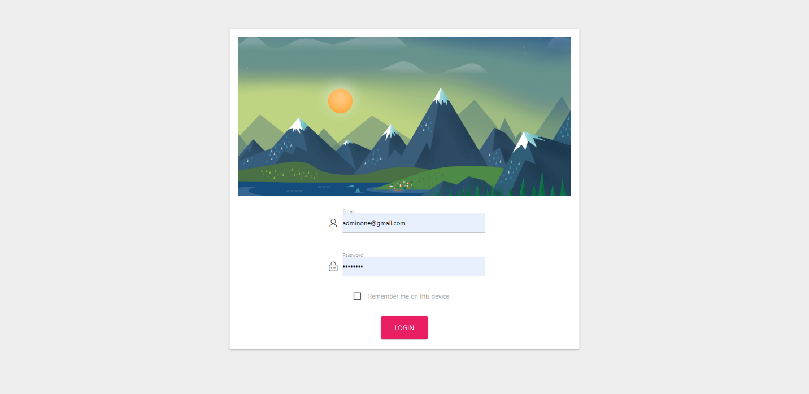

## Trader login with invalid details

Expected Result: Access denied

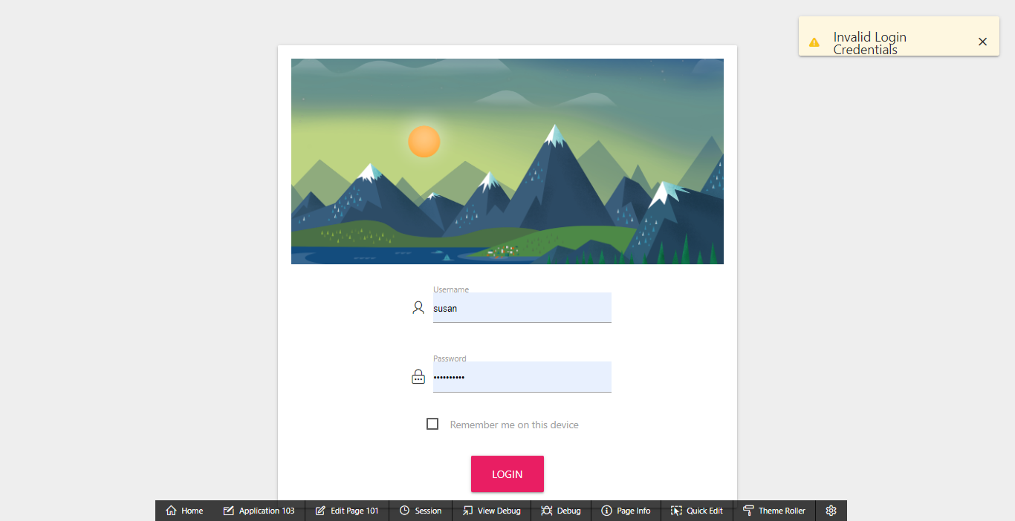

## View Dashboard

Expected Result: Traders can view dashboard with summary

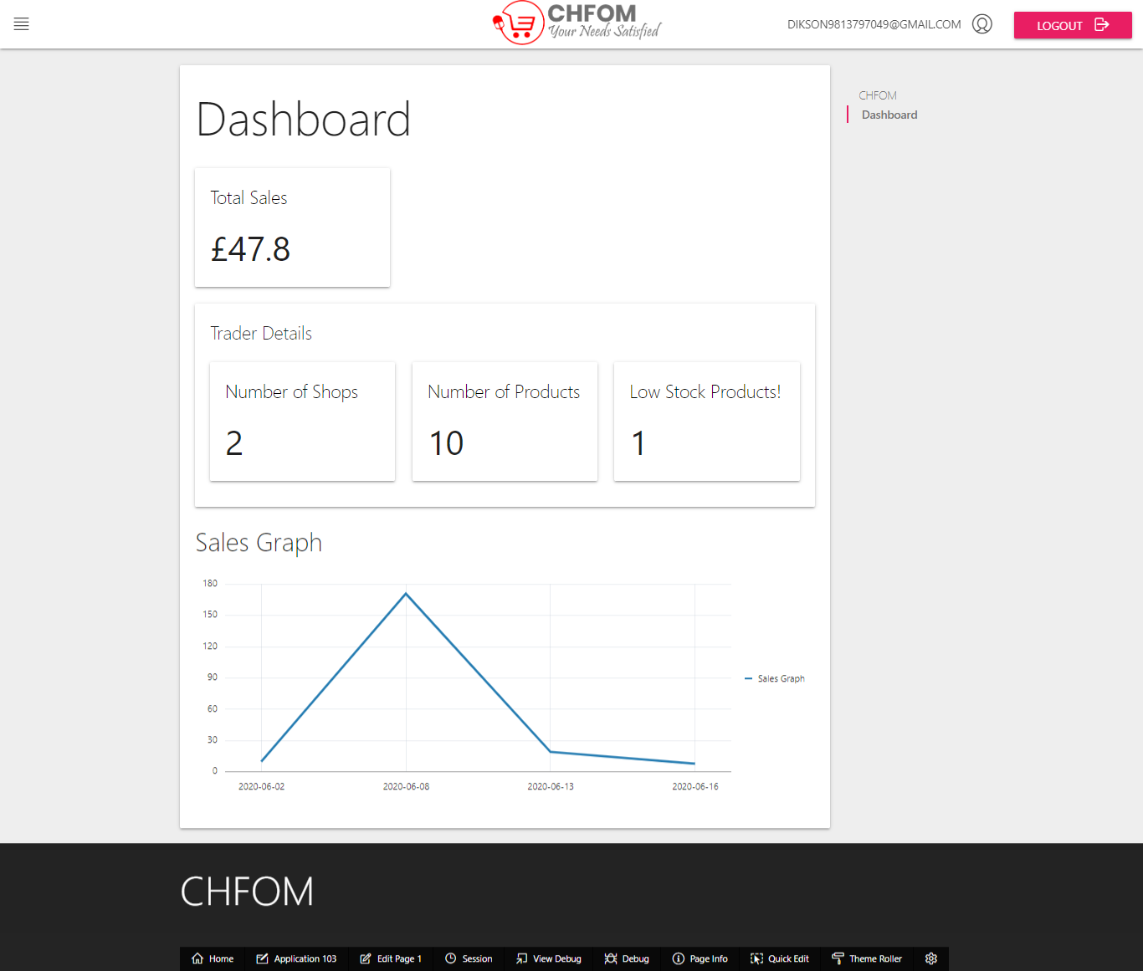

## View Order Details

Expected Result: Traders can view a report of orders for the day with required information

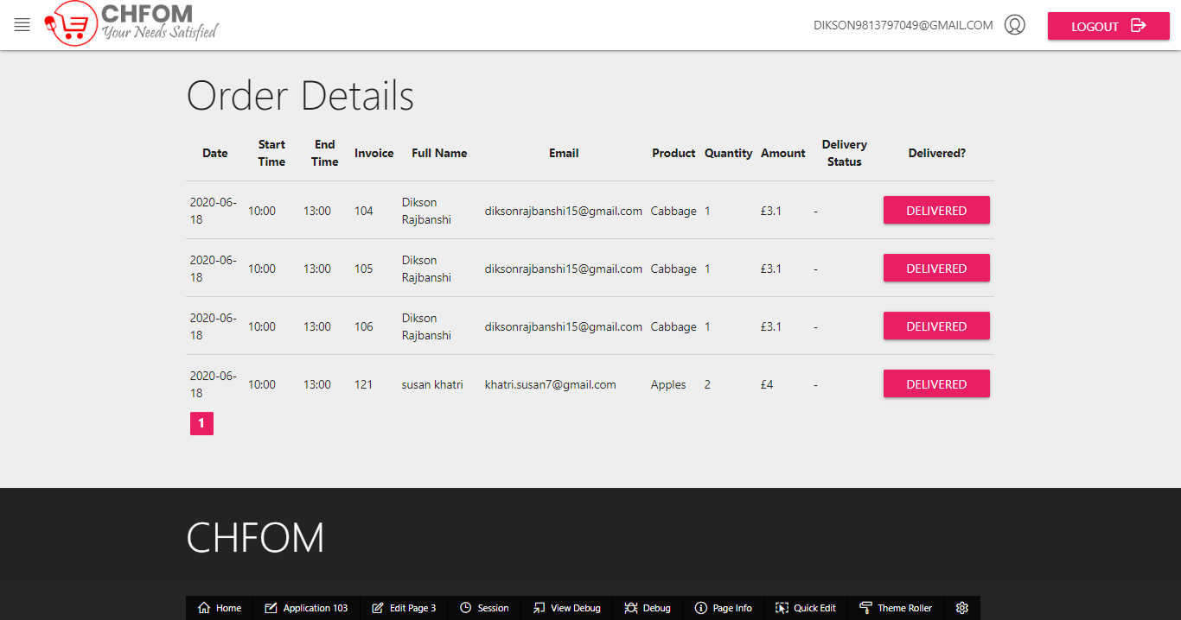

## View Product Report

Expected Result: Trader can view shop, products, and their details

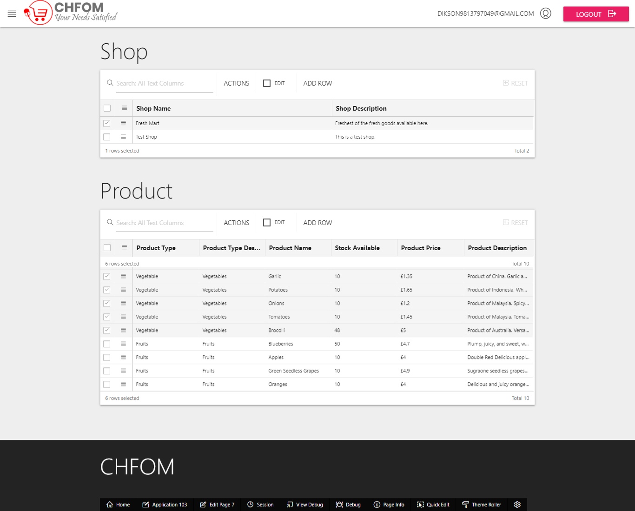

## View Stocks Report

Expected Result: Trader can view and update stocks with this report

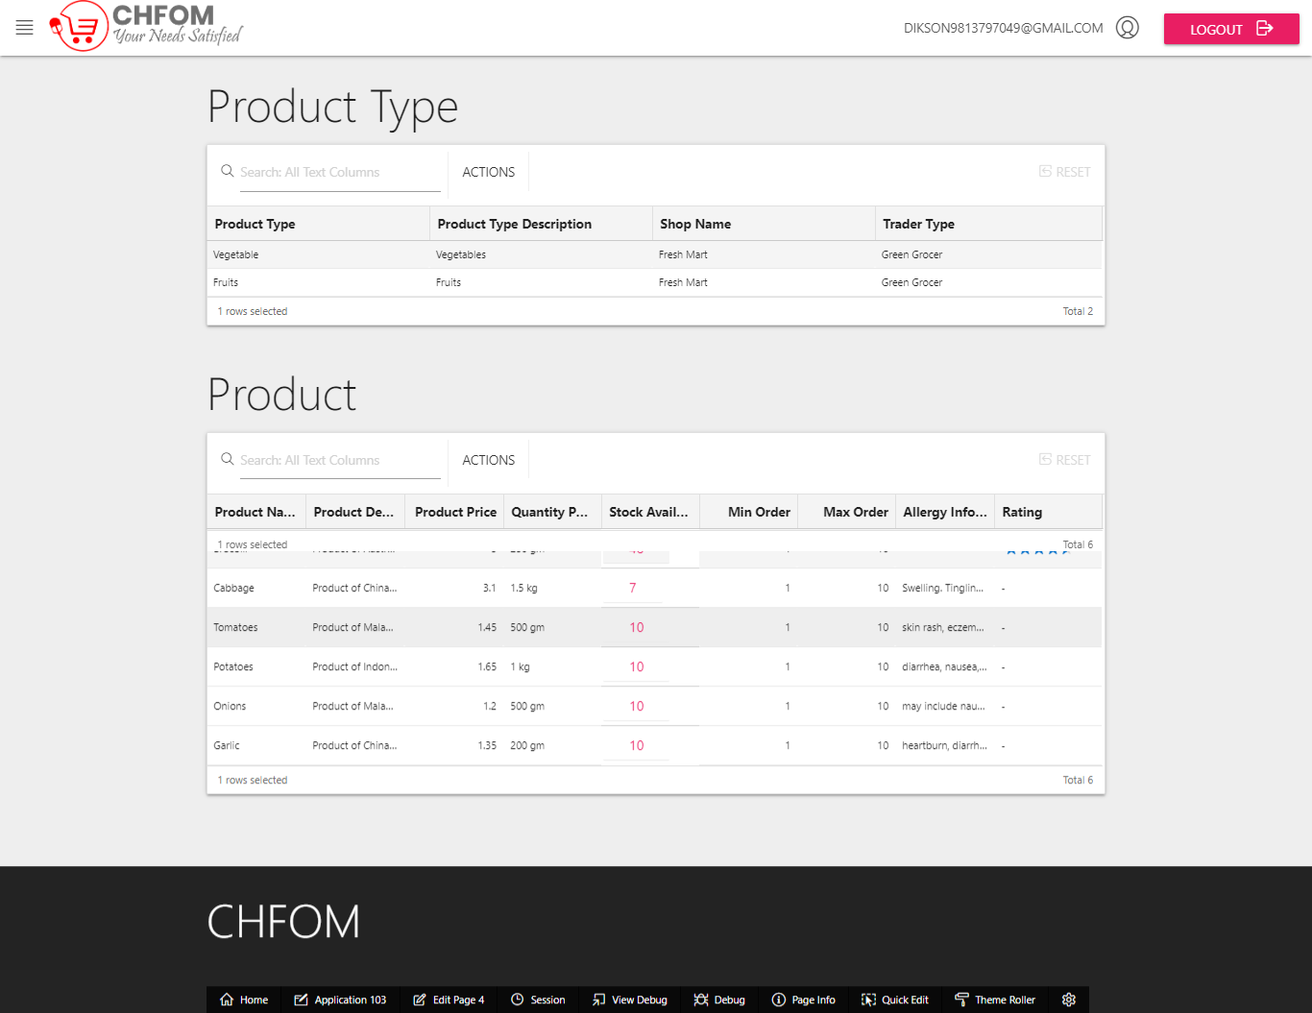

## Sales Report

Expected Result: Trader can see all the sales report

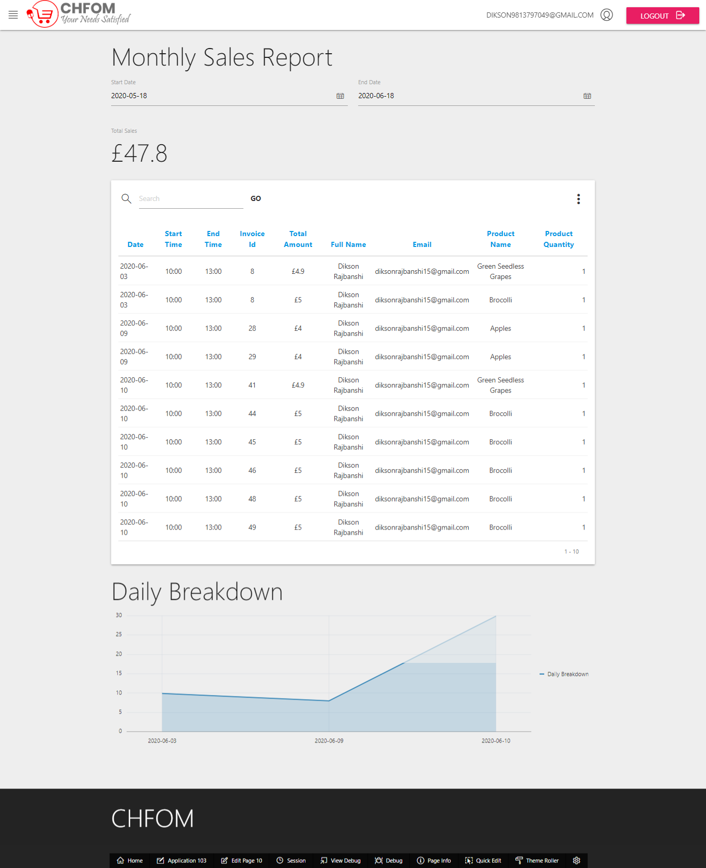

## View product reviews

Expected Result: Traders can view products review made by the customers

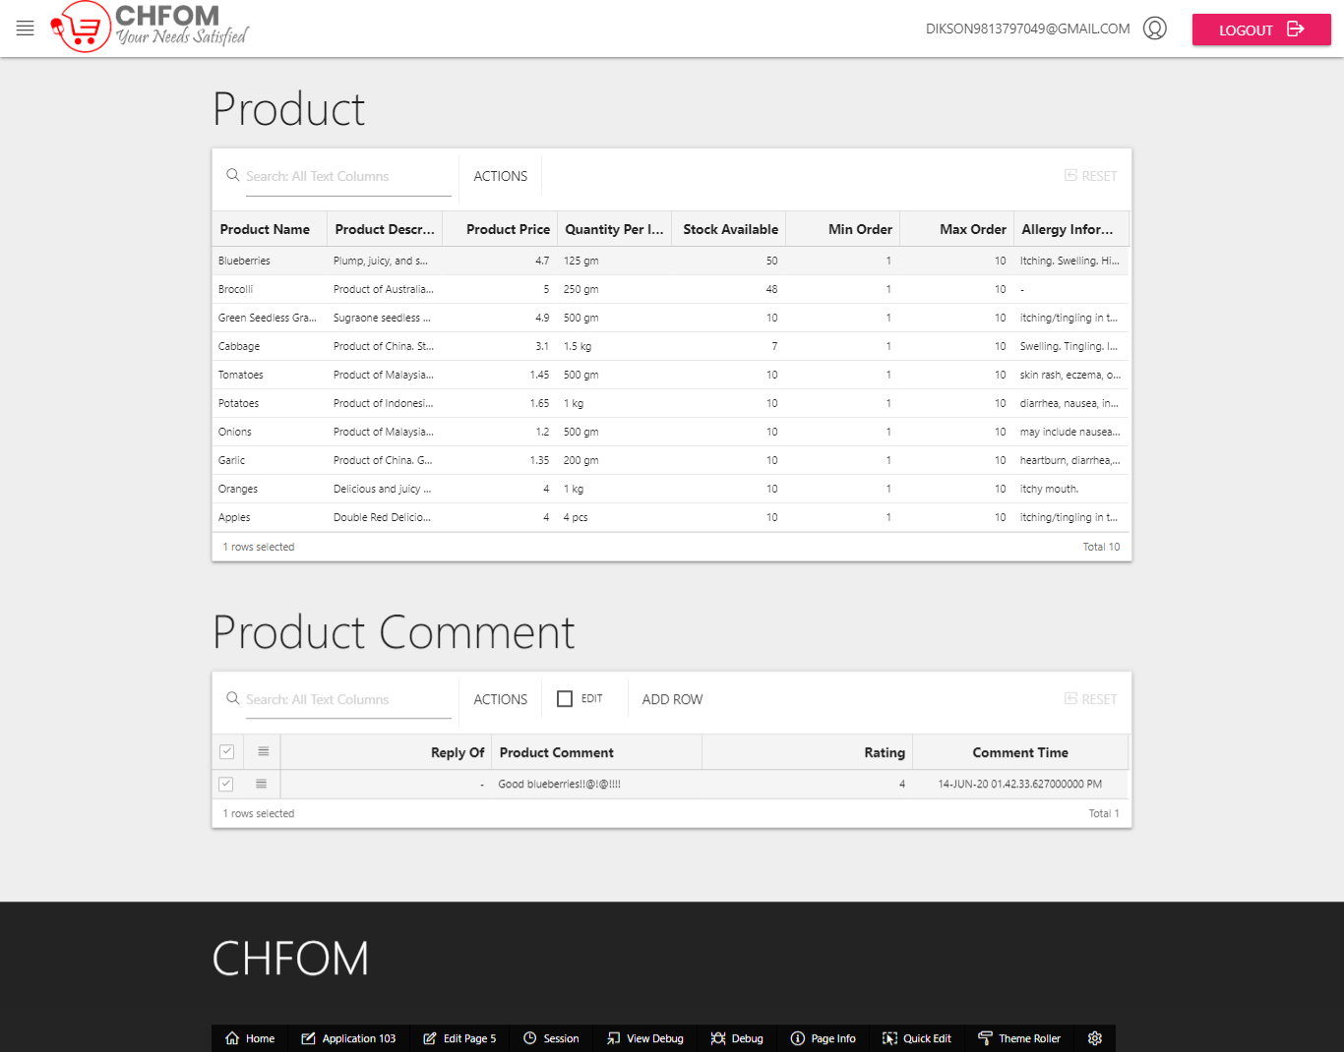

## Product Sales Report

Expected Result: Trader can see Total Orders Per Product, Total Income Per Product of products which can be sorted as required

